**Name – Parag Gattani**

Program No. – 08

Program Title – LDR

**AIM**

Demonstrate to show on/off of a LED using LDR night light simulation.

**HARDWARES REQUIRED**

* Arduino Board
* PhotoResistor
* Resistor
* LED
* Breadboard Small

**CIRCUIT DIAGRAM**

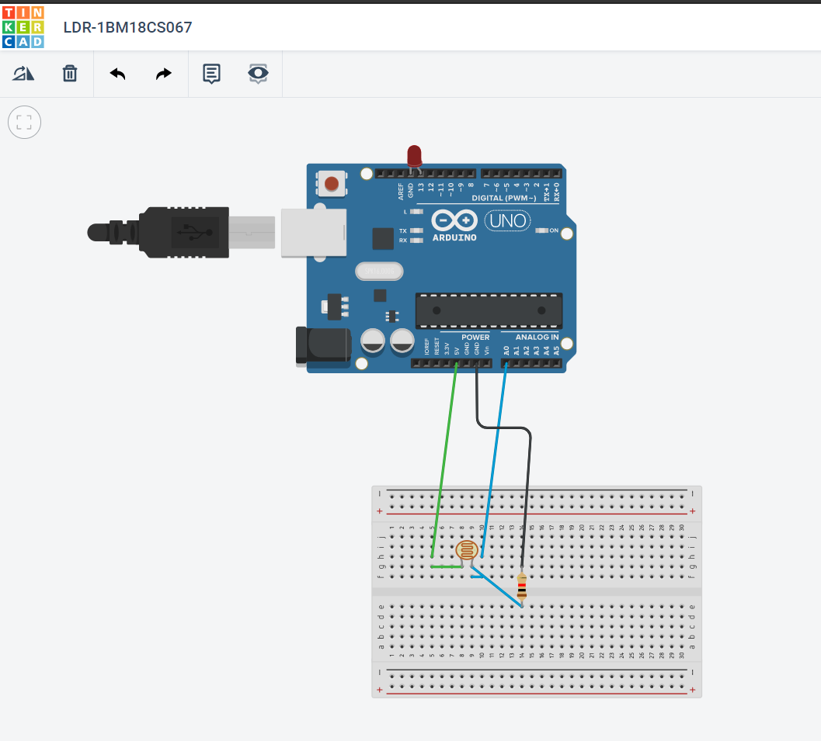

**WRITE-UP**

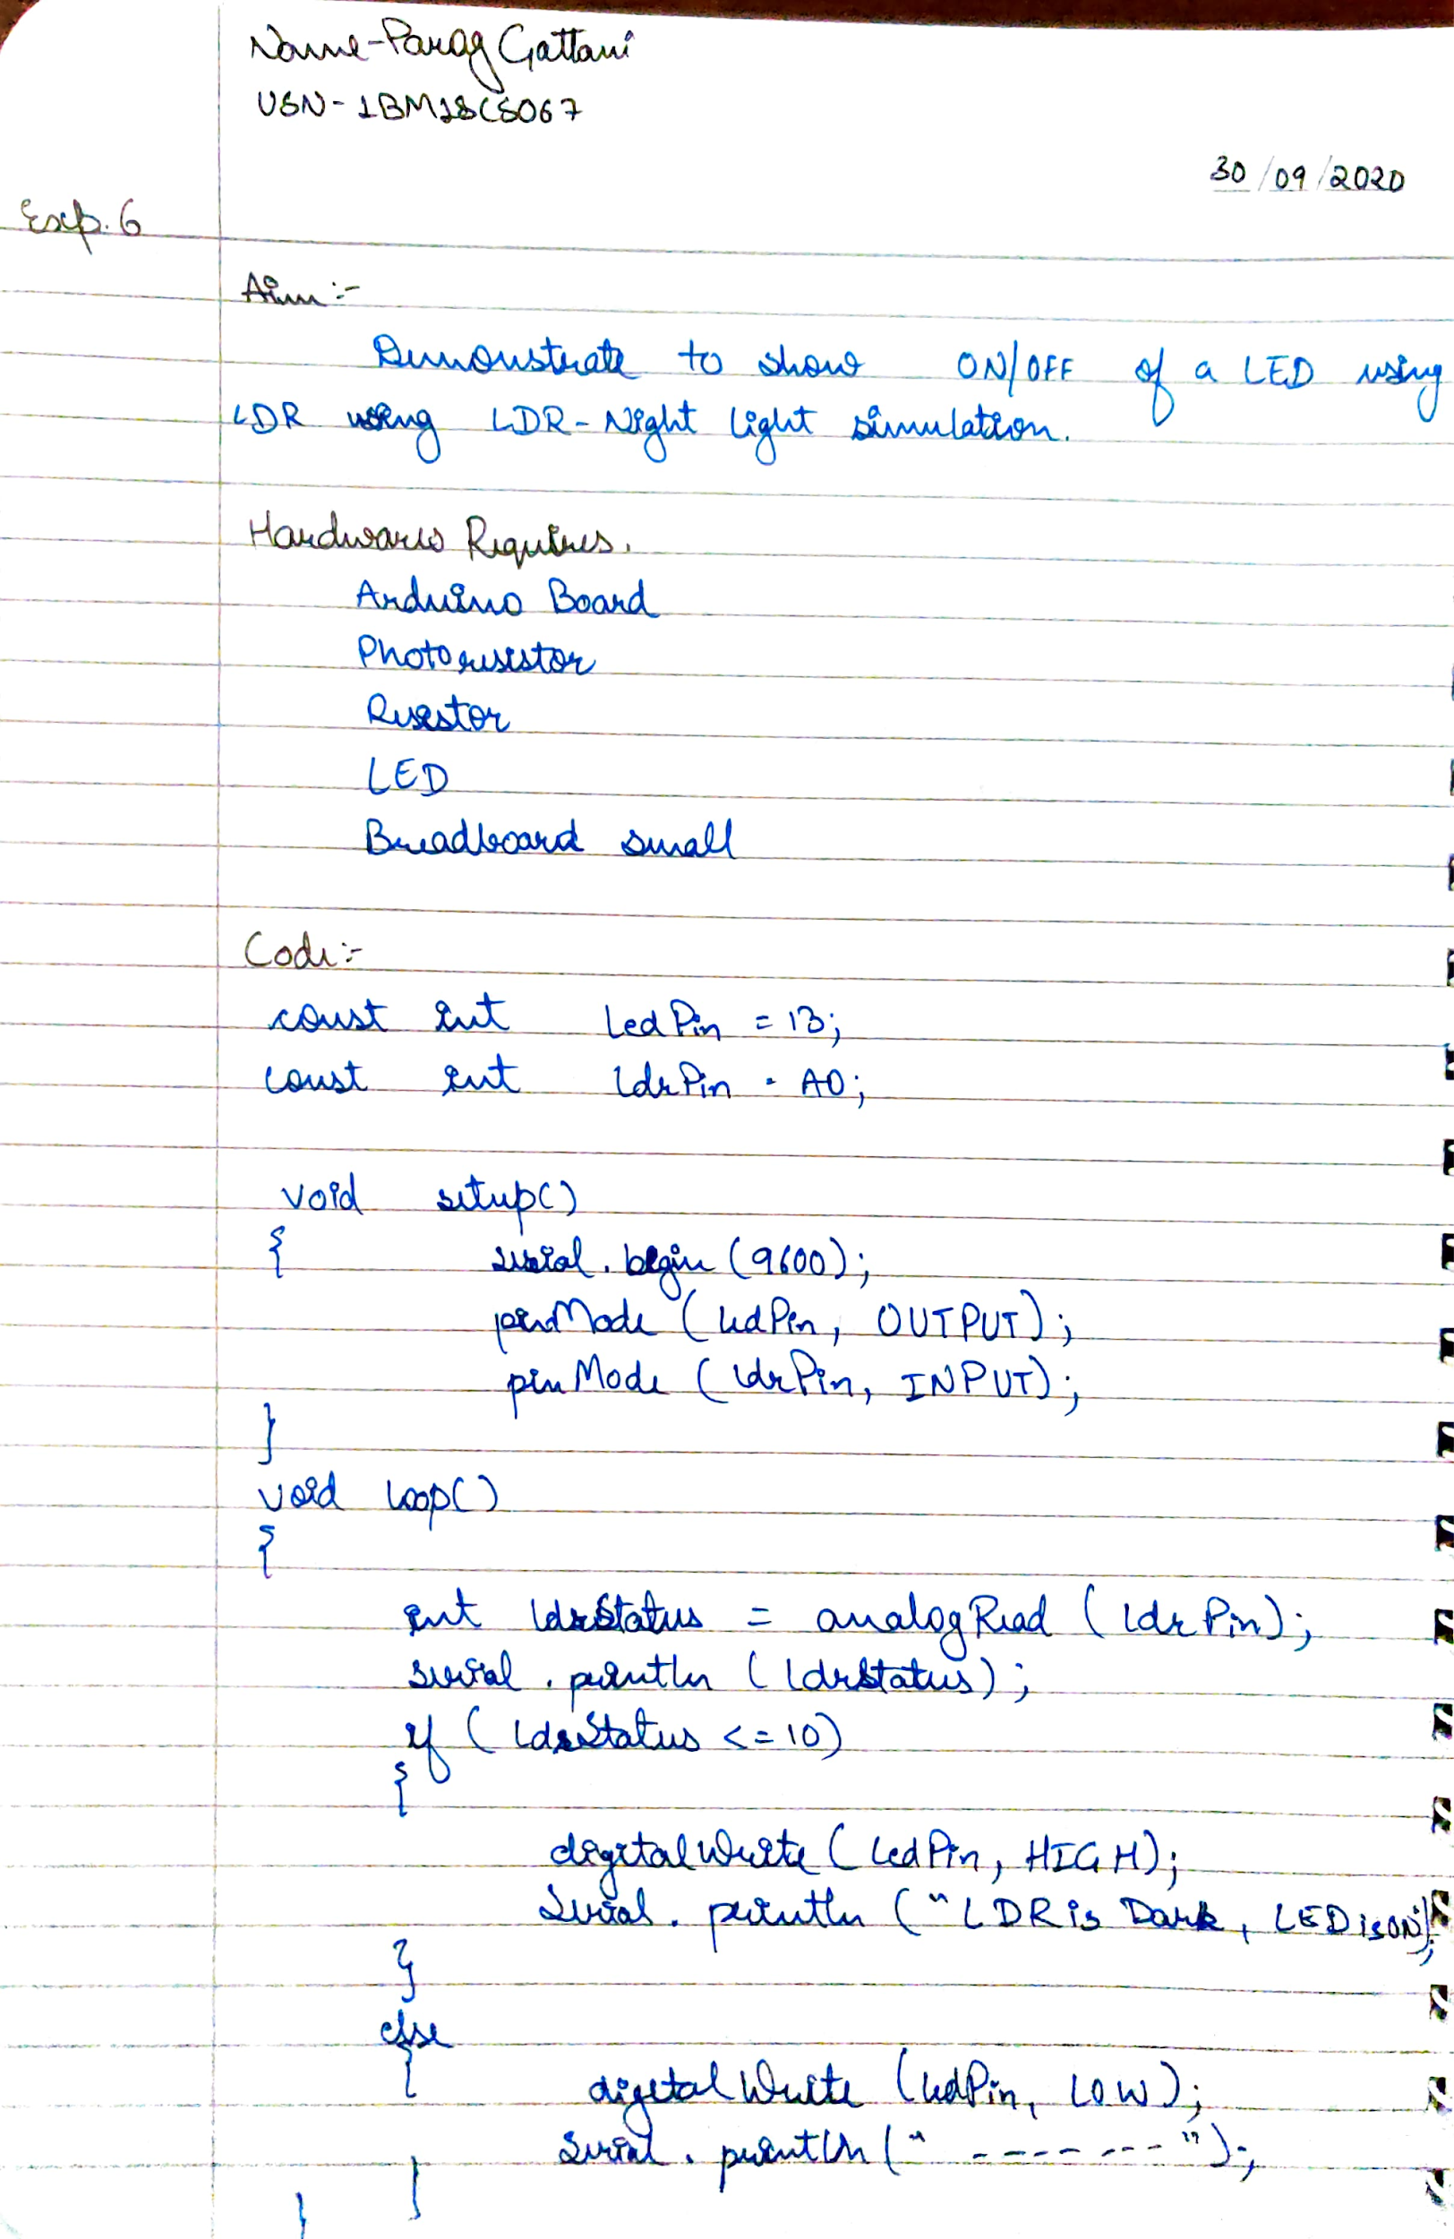

**CODE**

const int ledPin = 13;

const int ldrPin = A0;

void setup()

{

Serial.begin(9600);

pinMode(ledPin, OUTPUT);

pinMode(ldrPin, INPUT);

}

void loop()

{

int ldrStatus = analogRead(ldrPin);

Serial.println(ldrStatus);

if(ldrStatus <=10)

{

digitalWrite(ledPin, HIGH);

Serial.println("LDR is DARK, LED is ON");

}

else

{

digitalWrite(ledPin, LOW);

Serial.println("-----------------");

}

}

**OUTPUT**

Design a system to show on/off of a LED using LDR night light simulation.